Experiment:2

AIM: NFA to accept aaaaa

PROCEDURE

1. Start the automata
2. Enter the states
3. Connect the respective nodes (states) and self loop.
4. Enter the inputs values in the named nodes .
5. Compile the execution with suitable inputs
6. Stop the executions.

DESIGN INPUT:

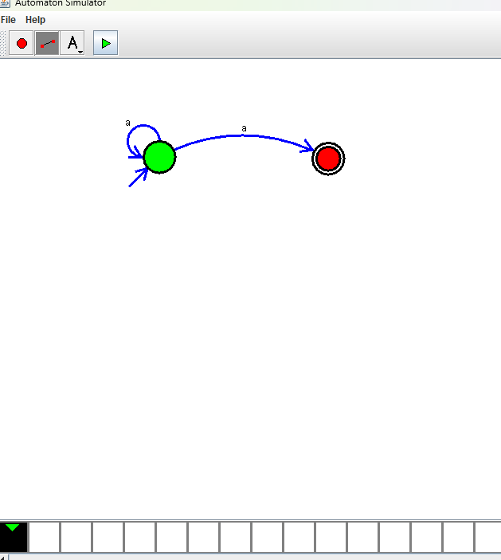

OUTPUT:

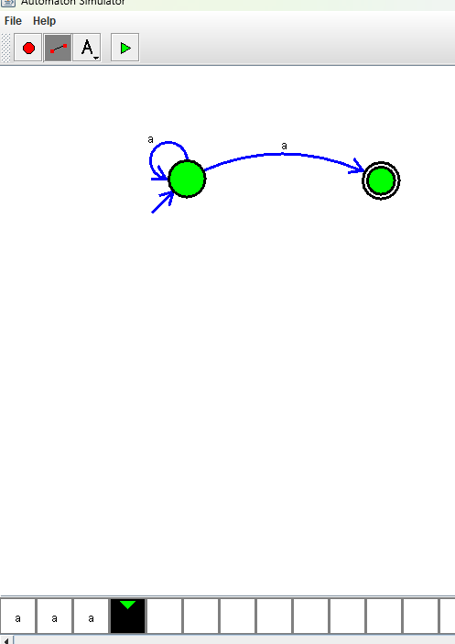

RESULT:

Thus the Design of NFA as been implemented and executed successfully.